Expt No. 1
Aim: Overview of MATLAB Software for Signal Processing

Theory:
In MATLAB, all variables are matrices. A scalar (single value) is just the special case of a 1 × 1 matrix. A vector is of course a matrix with one dimension equal to unity.
- Entering Matrix in MATLAB:

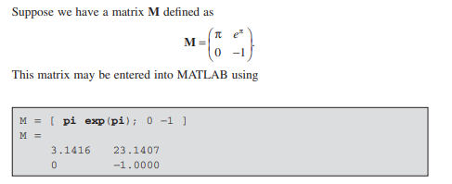

If we want the transpose of M , simply type M ’ . To transform a matrix to a vector “ column - wise, ” we type M(:) as shown below.

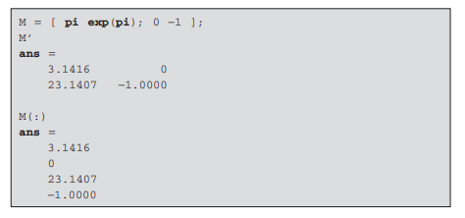

- Matrix and Vector product in MATLAB:
If we have a Vector v defined as
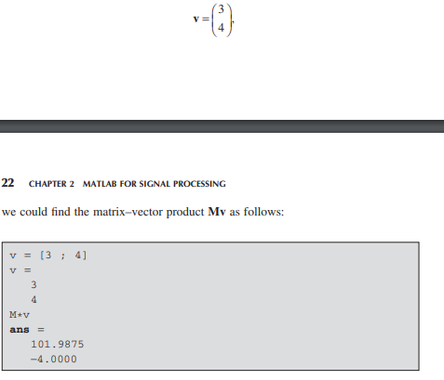
- Vector dot product or inner product in MATLAB:

Suppose we want the vector dot - product (also called the “ inner product ” ) i.e.,

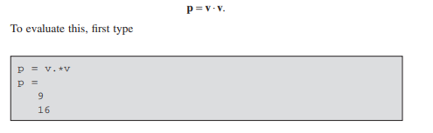

- Looping in MATLAB:

- If Loop:

The basic structure of if - then - else tests is explained below.
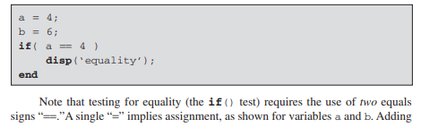

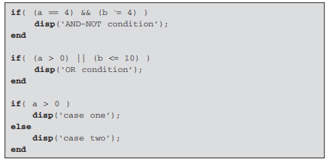
The first test is to determine whether a is equal to 4, and b is not equal to 4. The second test is true if a is greater than 0, or b is less than or equal to 10.

- For loop:

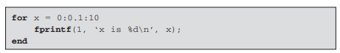

- While loop: It is typically used where the terminating condition for the iteration is calculated within the loop, rather than iterating over a fixed range of values as with the for loop.
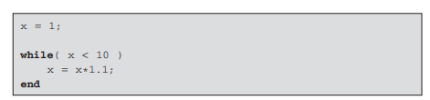

- Functions in MATLAB:

A function is a group of statements that together perform a task. In MATLAB, functions are defined in separate files. The name of the file and of the function should be the same.
Functions can accept more than one input arguments and may return more than one output arguments.
Syntax of a function statement is –
e.g.,
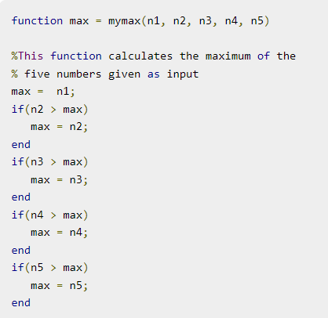
We can call this function as


